Project Design Phase
Solution Architecture

Date | 06/02/2026
Team ID | LTVIP2026TMIDS80883
Project Name | Prosperity Prognosticator: Machine Learning for Startup Success Prediction
Maximum Marks | 4 Marks

Solution Architecture:
1. User & UI
- User provides inputs through the interface.
- Receives predictions from the system.
2. Inputs & Model
- Inputs are fed into the ML model.
- Model applies learned patterns to generate predictions.
3. Prediction
- Output from the model sent back to the user via UI.
4. Data & Preprocessing
- Raw data (CSV) is cleaned, transformed, and split into train and test sets.
5. Algorithm & Training
- Algorithm trains the model using train data.
- Test data evaluates model performance (accuracy, metrics).
6. Evaluation
- Ensures the model predicts correctly before deployment.
Flow: Data → Preprocessing → Train/Test → Model → Evaluation → Prediction → User.

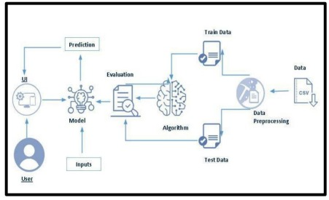
Solution Architecture Diagram:
Figure 1: Architecture and data flow diagram

